**SPRINT 2**

|  |  |
| --- | --- |
| Date | 05 November 2022 |
| Team ID | PNT2022TMID33811 |
| Project Name | Project – Smart Farmer-IoT Enabled smart Farming Application |

## Creating device in the IBM Watson IoT platform, workflow for IoT scenarios using Node-Red and setting up Open Weather API.

1)A DEVICE IS CREATED USING THE IBM WATSON PLATFORM :

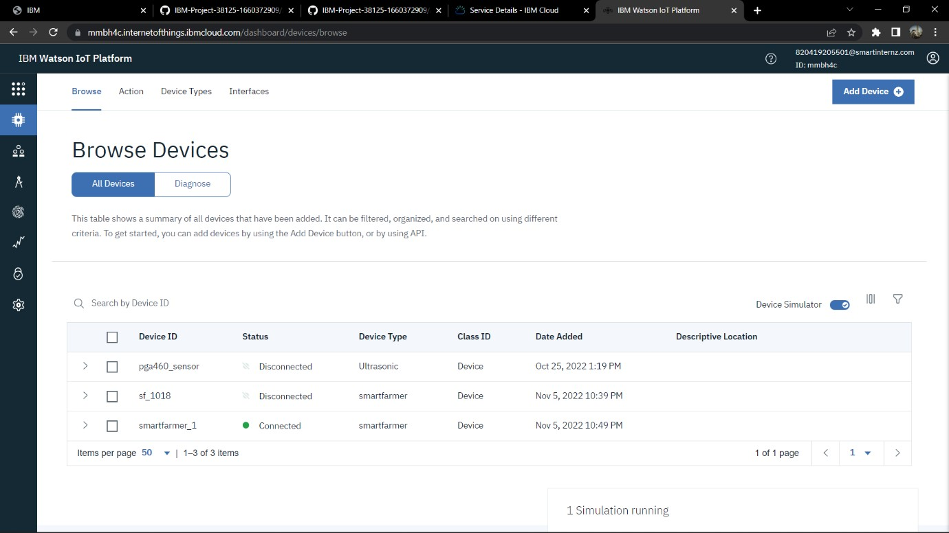

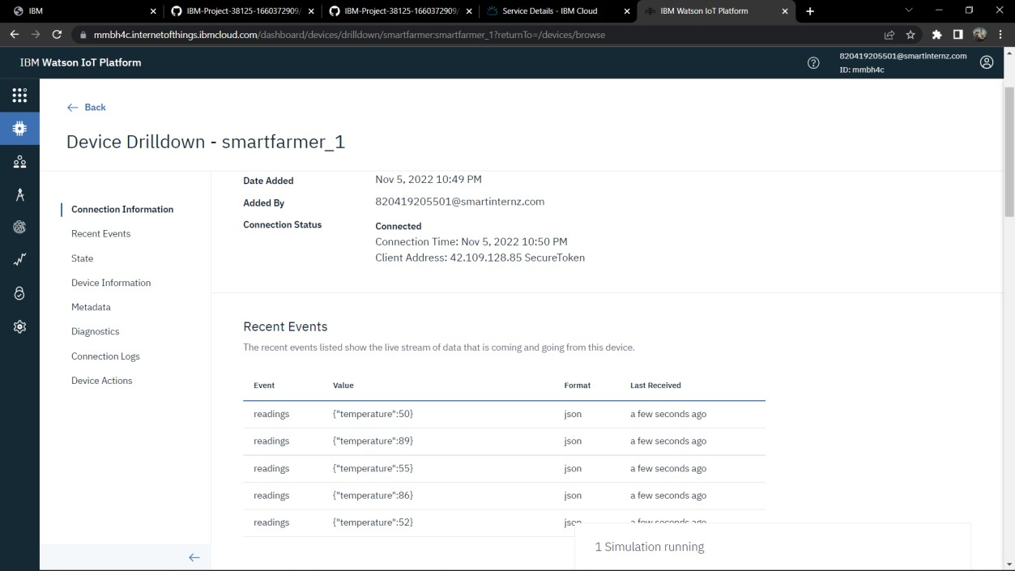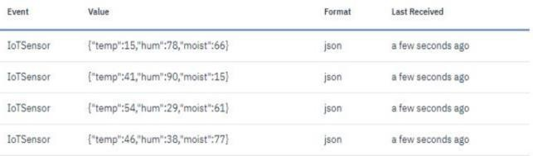

2) THE DETAILS OF THE CONNECTION IS DISPLAYED:

3)NODE RED IS USED TO DISPLAY THE WORKFLOW FOR IOT SCENARIO:

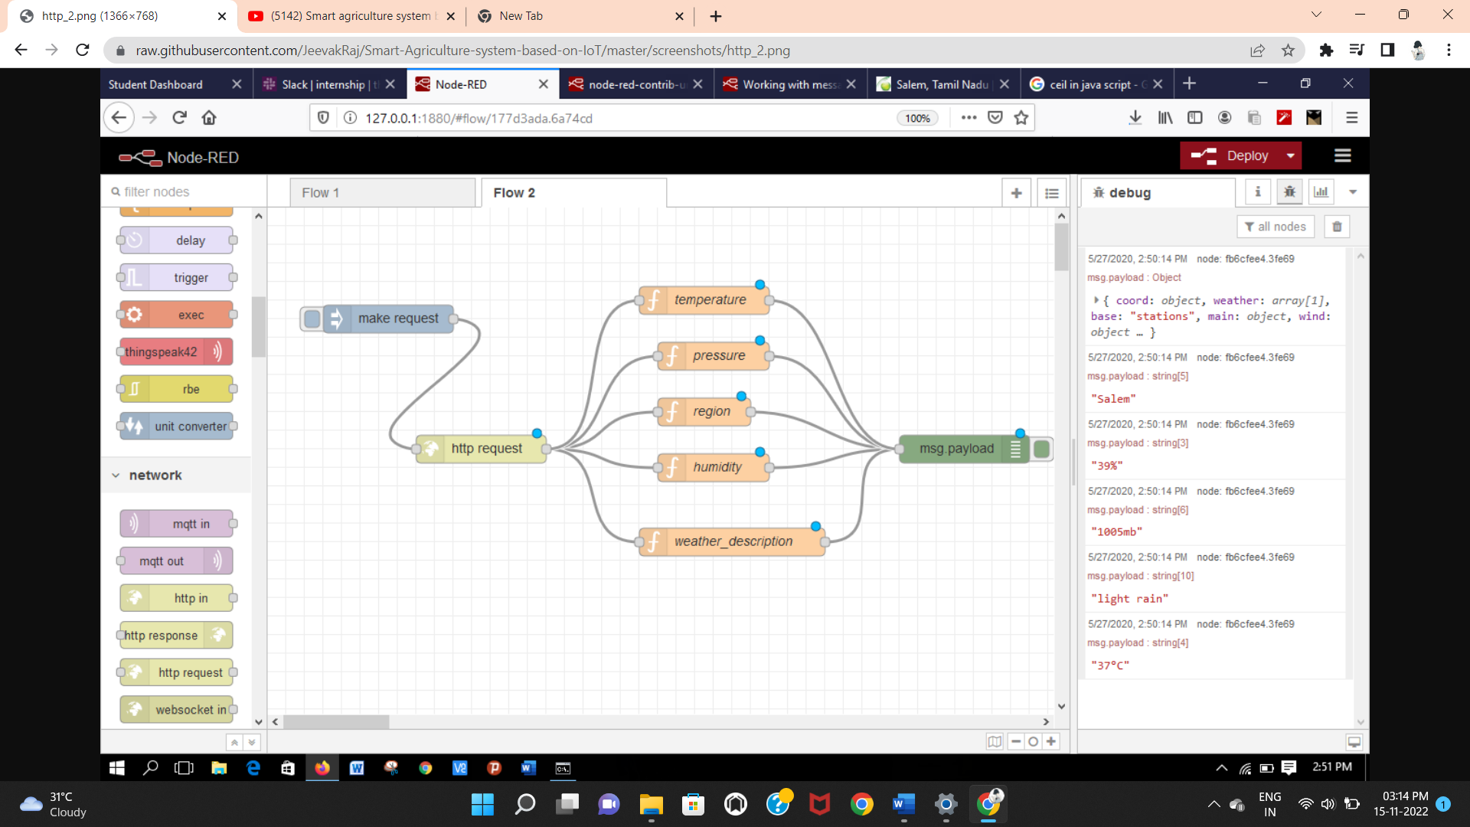

4)WORKFLOW IS SUCCESSFULLY DEPLOYED USING NODE RED:

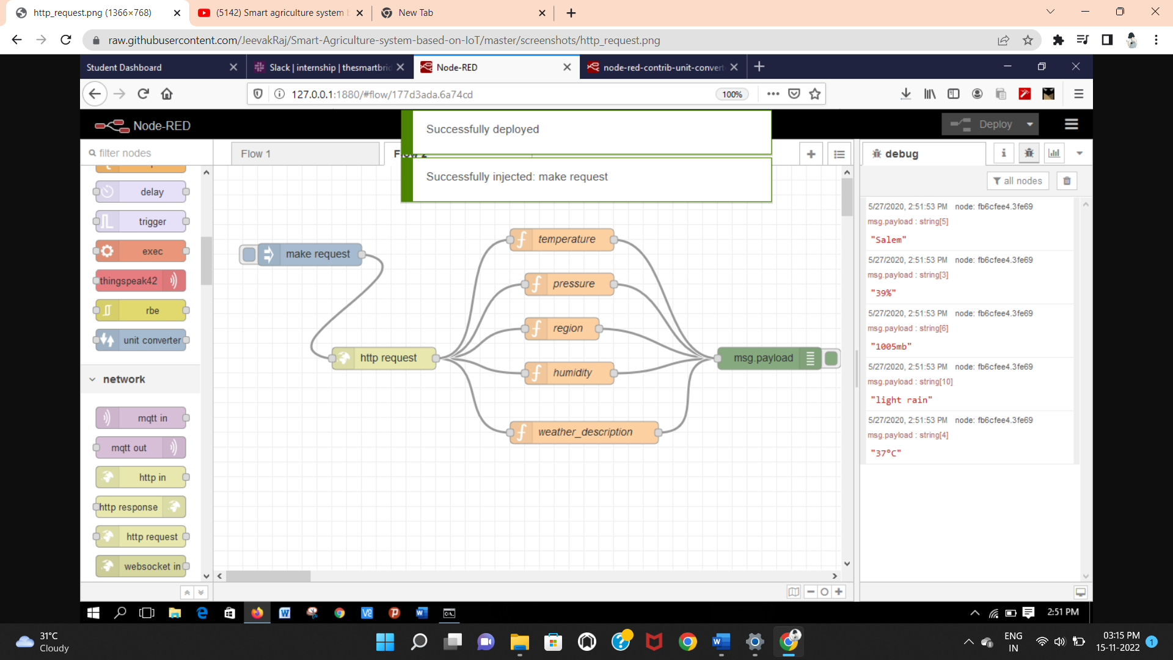

5)IBM IOT IS CONNECTED SUCCESSFULLY:

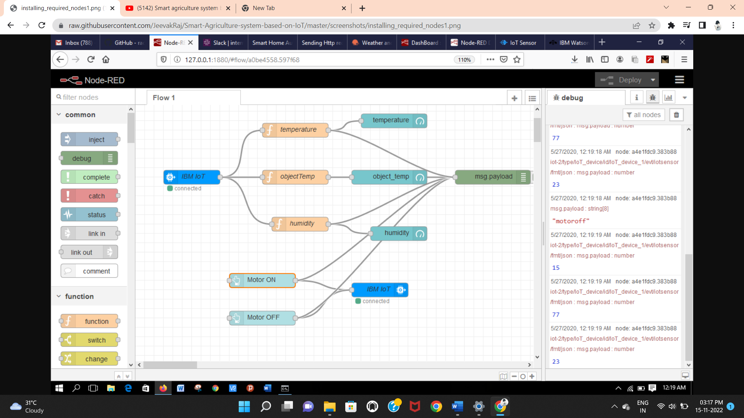

6)OPEN WEATHER API IS SET UP:

